Especificación de Requisitos – Gestor Financiero

|  |  |
| --- | --- |
| NA |  |
| NA | Date: abril 24, 2019 |

**Revision History**

|  |  |  |  |
| --- | --- | --- | --- |
| **Revision** | **Date** | **Reason For Changes** | **Author** |
| 1.0 | NA | NA | NA |
| 0.1 | NA | NA | NA |
|  |  |  |  |

**Table of Contents**

Introduction 5

Purpose 5

Scope 5

Overview 5

FR diagram 6

NFR diagram 7

**Table of Figures**

Figure 1. FR diagram 6

Figure 2. NFR diagram 7

**Executive Summary**

This section previews the main points of a report. The executive summary contains enough information for a reader to get familiarized with what is discussed in the full report without having to read it.

# Introduction

## Purpose

<This document provides requirements with their properties including requirement id, requirement name, requirement text and the dependencies.>

## Scope

<Provide a short description of the system being specified and its purpose, including relevant benefits, objectives, and goals.>

## Overview

<Describe what the document contains and explain how the document is organized>

# FR diagram

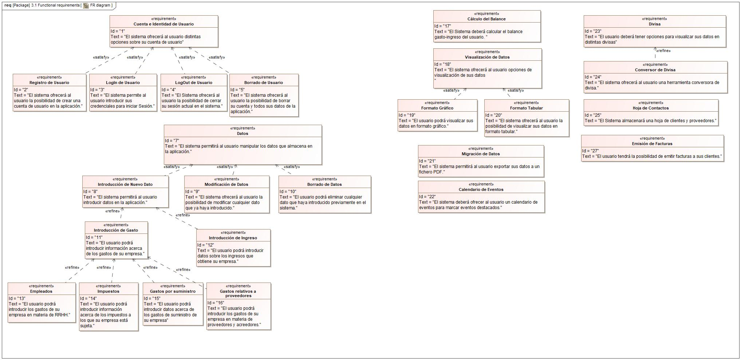

1. FR diagram

List of Requirement

# NFR diagram

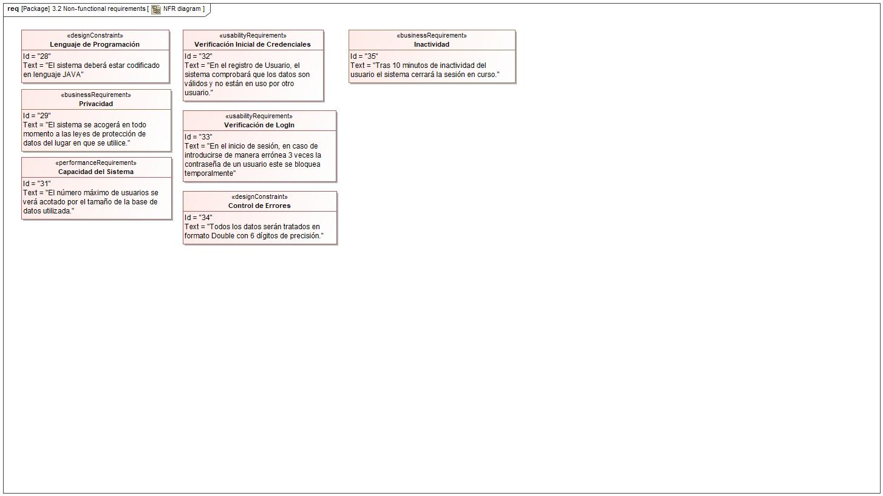

1. NFR diagram

List of Requirement